**Project Name:**

MoviesStation Website

**Supervised by:**

Mohamed Magdy Mohamed Elkomy

**Table of Contents**

***Chapter 1: Introduction*** 3

1.1.1 Project Purpose 3

1.1.2 Project Scope 4

1.1.3 Glossary and Abbreviations 4

***Chapter 2: System Design and Analysis*** 5

2.1 Use-Case Diagram 5

2.2 Site-Map 6

2.3 Sequence Diagram 7

2.4 Activity Diagram 10

***Chapter 3: System UI/UX Design*** 11

***Chapter 4: System Testing*** 17

4.1 Open a movie and run the video player 17

4.2 Valid email and password 17

# ***Chapter 1: Introduction***

### 1.1.1 Project Purpose

Movie Station is a free streaming service that allows our members to watch movies and TV shows with commercials on an internet-connected device.

These contents are downloadable on iOS, Android, or Windows devices and watch without an internet connection with a variety of qualities and subtitles. The website content varies by region and changes over time, there is a wide kind of award-winning Netflix Originals, Disney+ Originals, HBO MAX Originals, AMC Originals, TV Shows, Movies, documentaries, and more are combined in one website instead of many.

Movie Station supports smart TVs, streaming media players, set-top boxes, smartphones, and tablets; to achieve the best performance you can review the system requirements for web browser compatibility and check our internet speed recommendations for better streaming quality.

This Website is implemented using WordPress gives the option to customize the website without touching lines of codes, API DB Movies plugin support that’s used to crawl TV Shows and Movies data from the TMDB database, API IMDb support that’s used to crawl TV Shows and Movies data from the IMDb database.

**Users:**

1. **Admin**

* data (add, delete).
* view user’s account logs and account summary (show).

1. **End-Users**

* Stream Movies/TV shows.
* Review and comment on posts.
* Login and manage account.

### 1.1.2 Project Scope

The system design is implemented with Vue.js and is designed as a dynamic and interactive website. The online streaming service system deals with **data load**, **validation confirmation,** and **updating** whiles the interactive system deals with system interaction with the administration and users. Thus, the above features of this project will save transaction time and therefore increase the efficiency of the system.

### 1.1.3 Glossary and Abbreviations

* **End-User:** Anyone can access and use the website.
* **Admin:** The admin who manages the system and servers.
* **Database:** is an organized collection of structured information.
* **SQL:** stands for Structured Query Language. SQL is used to communicate with a database that holds thousands of movies and TV shows.
* **UI/UX:** user interface and user experience, which is the page that the user sees and interacts with dynamically.

# ***Chapter 2: System Design and Analysis***

### Use-Case Diagram

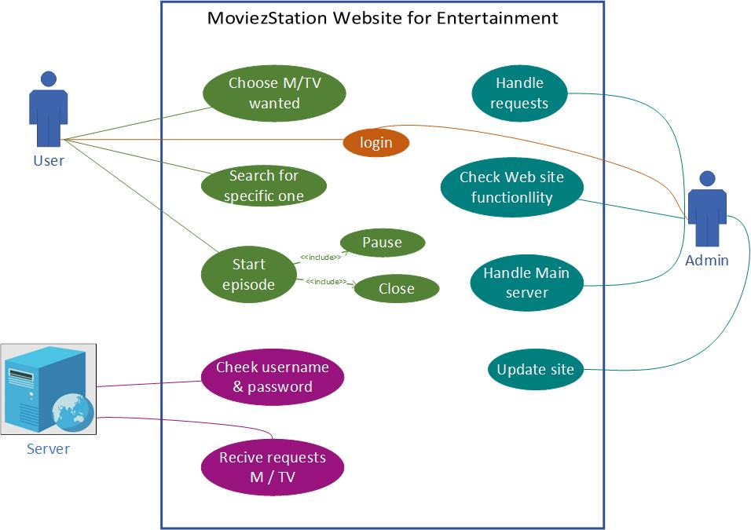

### 2.2 Site-Map

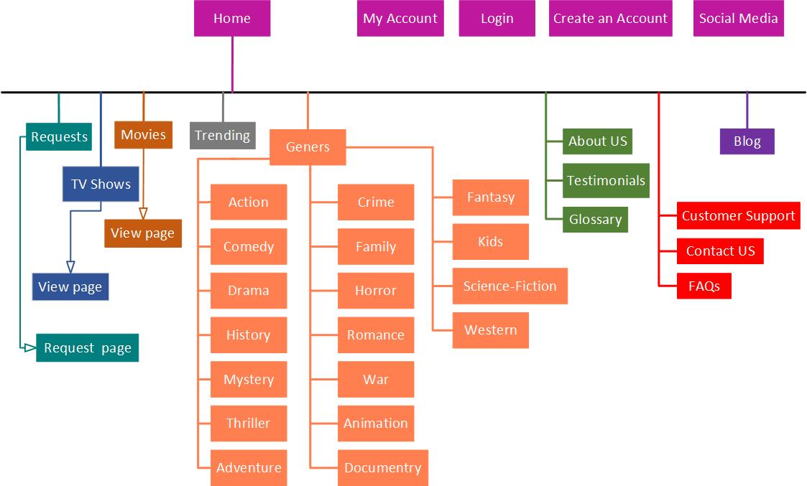

### 2.3 Sequence Diagram

**Account login**

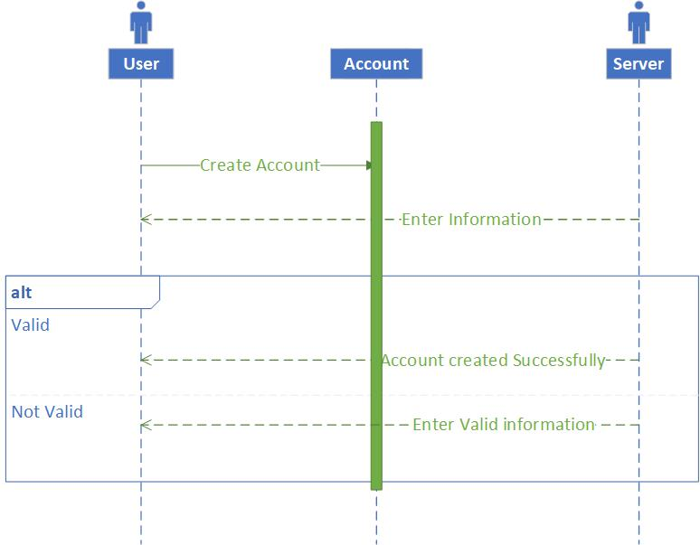

1. User input email and password
2. Server checks whether the email exists or not
3. If the account exists then create the account, otherwise shows an error message to enter a valid or new email.

**Search a movie/series**

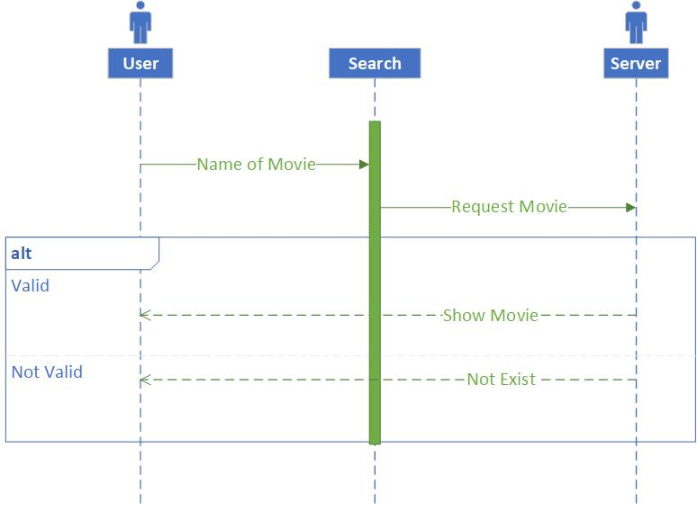

User Search the name of the movie, then the server checks whether the movie exists in the database or not.

If the movie exists then open the movie page and load the player, otherwise shows an error message that the movie doesn’t exist.

**Open the video player to watch a movie**

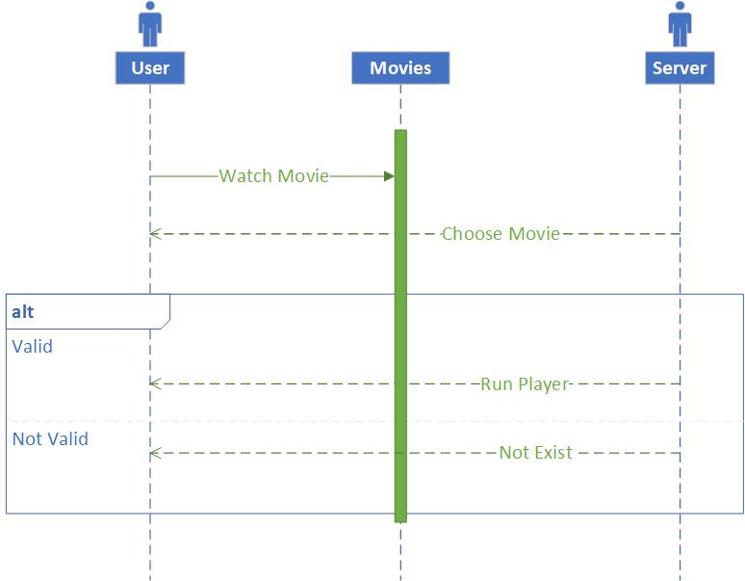

1. User chooses a movie from the movies page
2. If the movie exists in the database, then the video player opens and loads the movie, otherwise an error message shows indicating that the movie doesn’t exist.

### 2.4 Activity Diagram

**User Search for a movie/series and login**

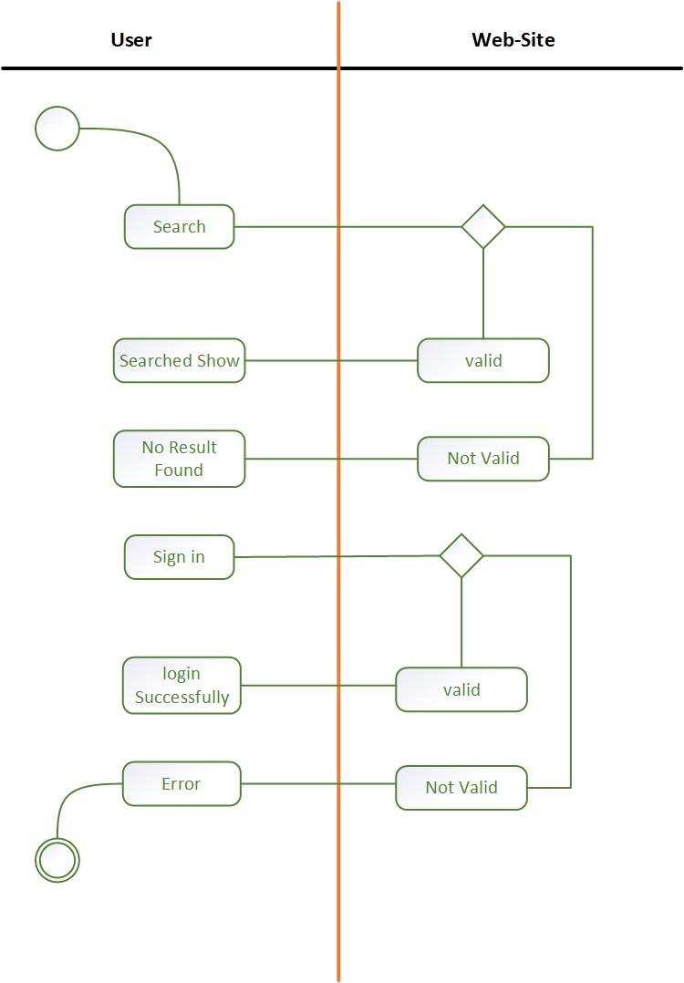

# ***Chapter 3: System UI/UX Design***

**HOME Screen: contains the categories of shows (1).**

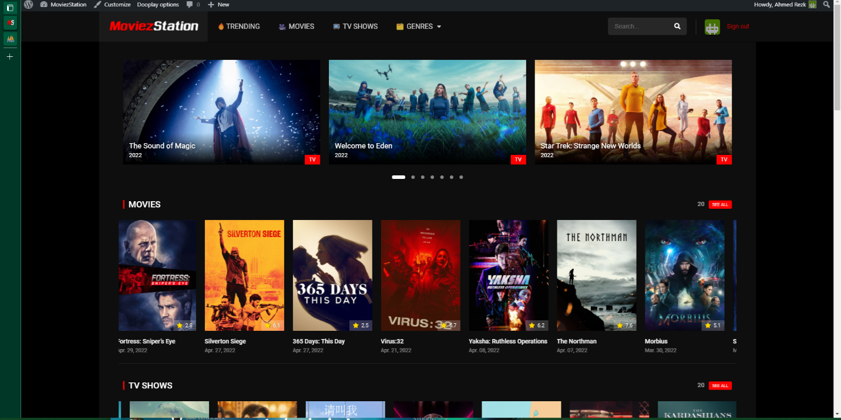

**Trending CCategory contains the trending shows (2).**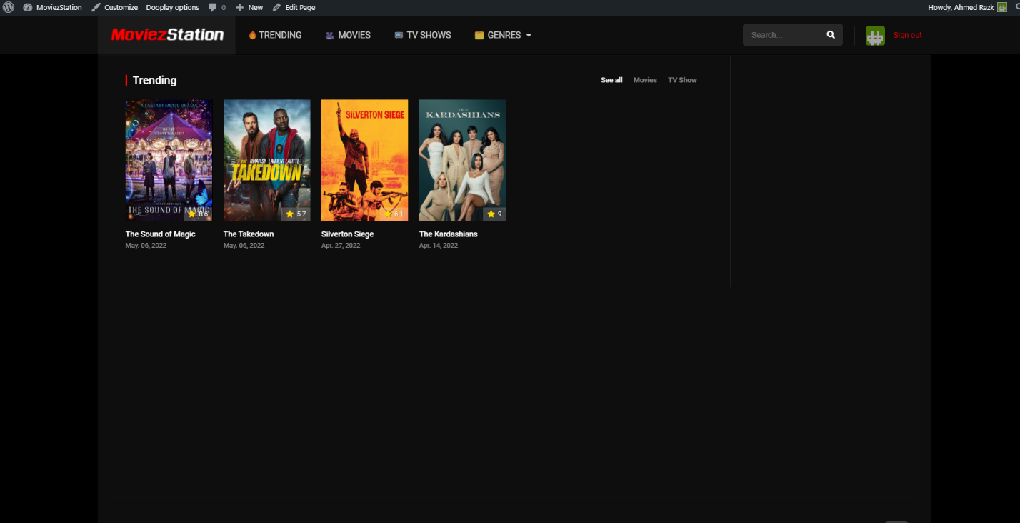

**Genres Dropbox: contains all shows genres (3).**

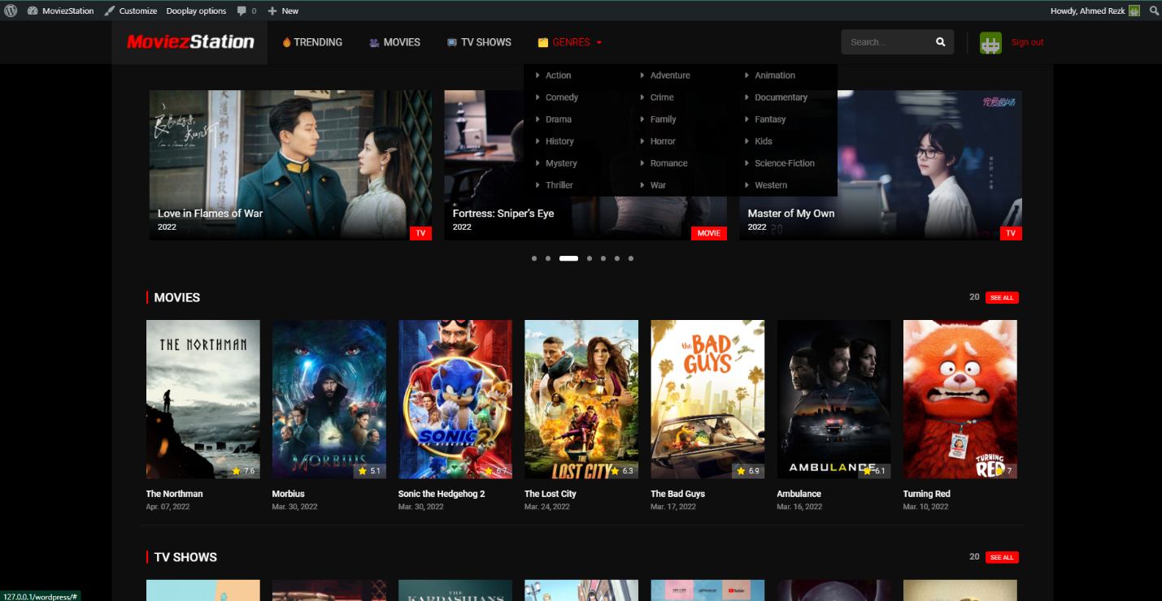

**Recently Added: contains the recently added shows on the site (5).**

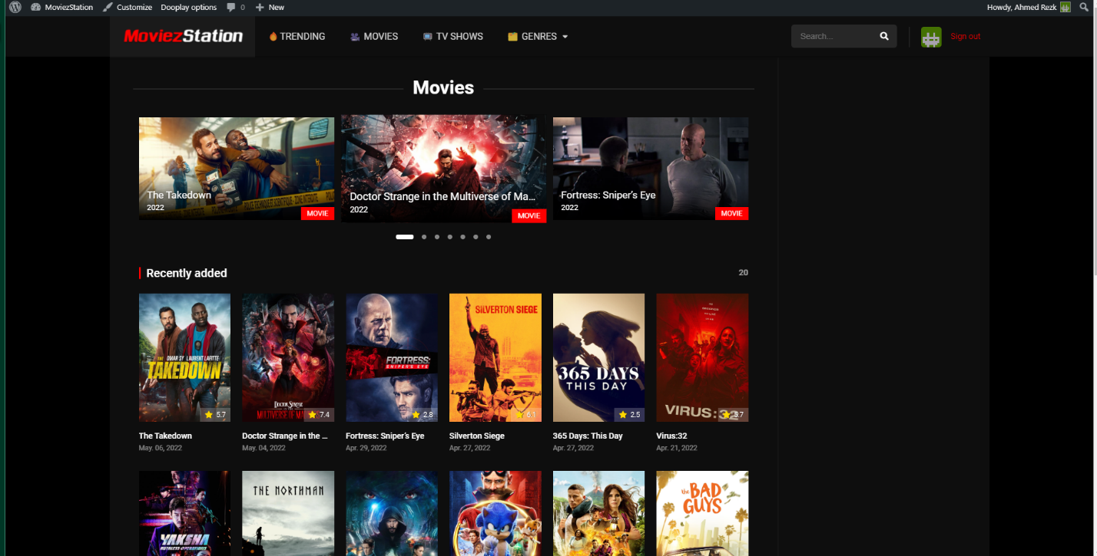

**Search box: This helps you to access the show you want by searching its name (6).**

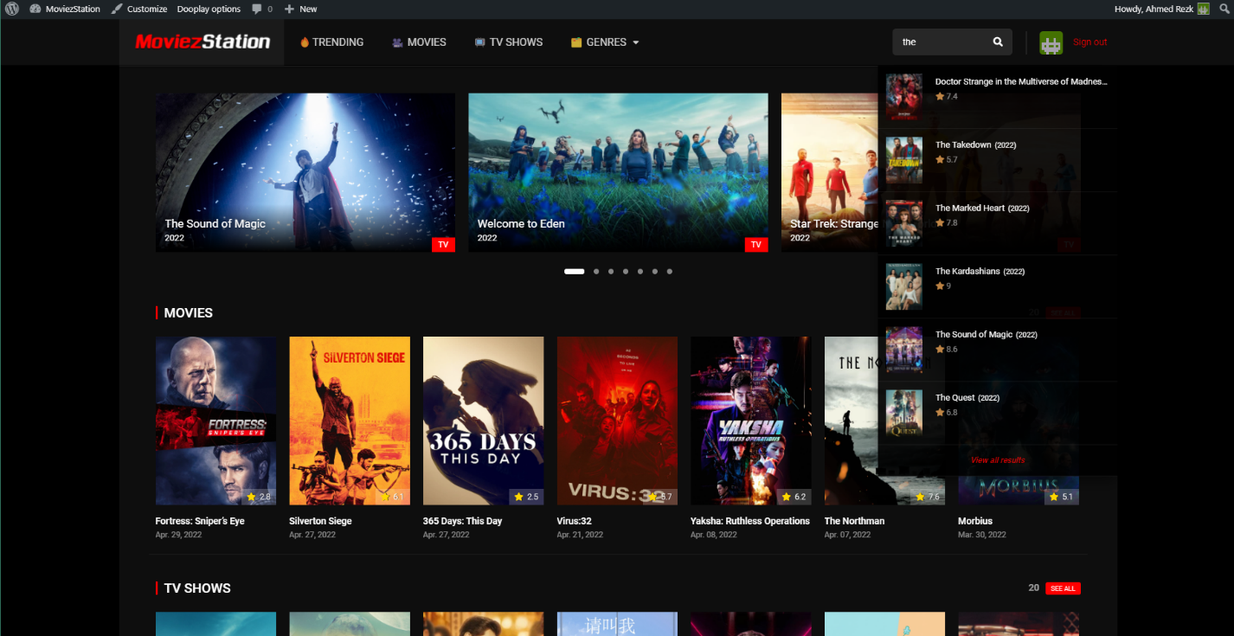

**Video player: page that contains the video player won which the show is being watched (8).**

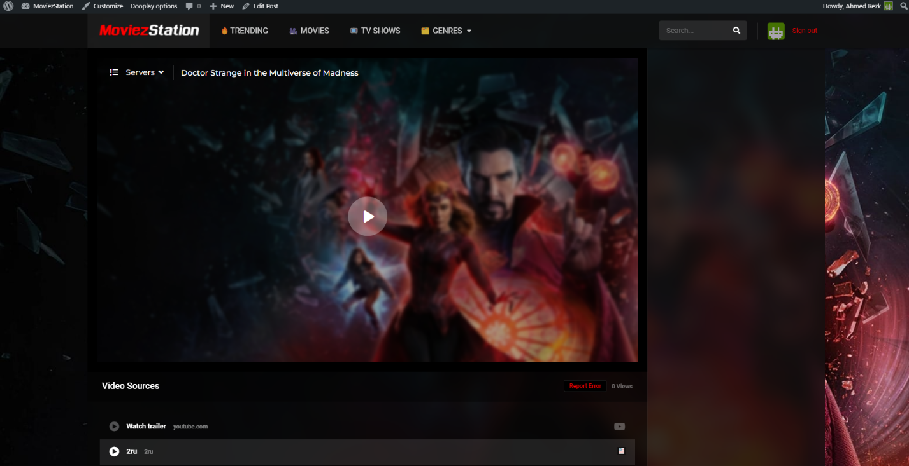

**PagThe pageat contains the show information and rating (7) :**

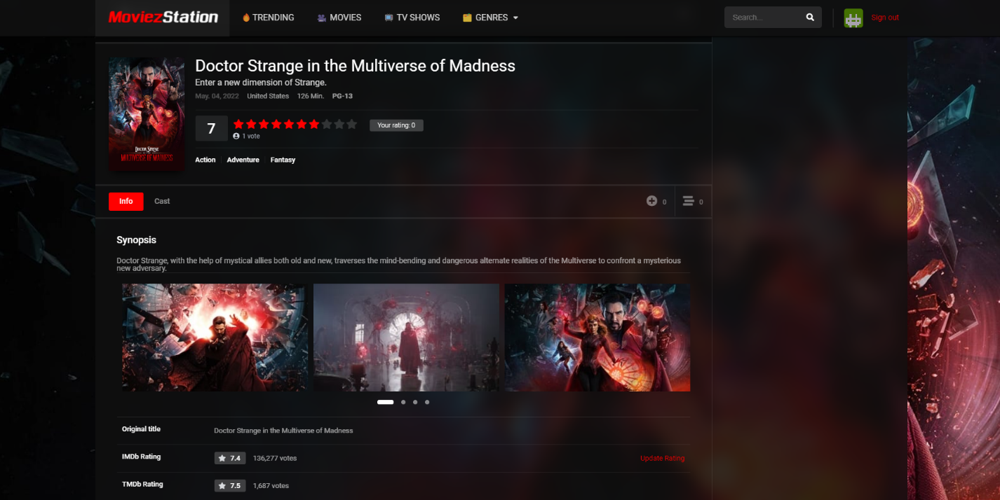

On

**In this page you can leave a comment on the show (9):**

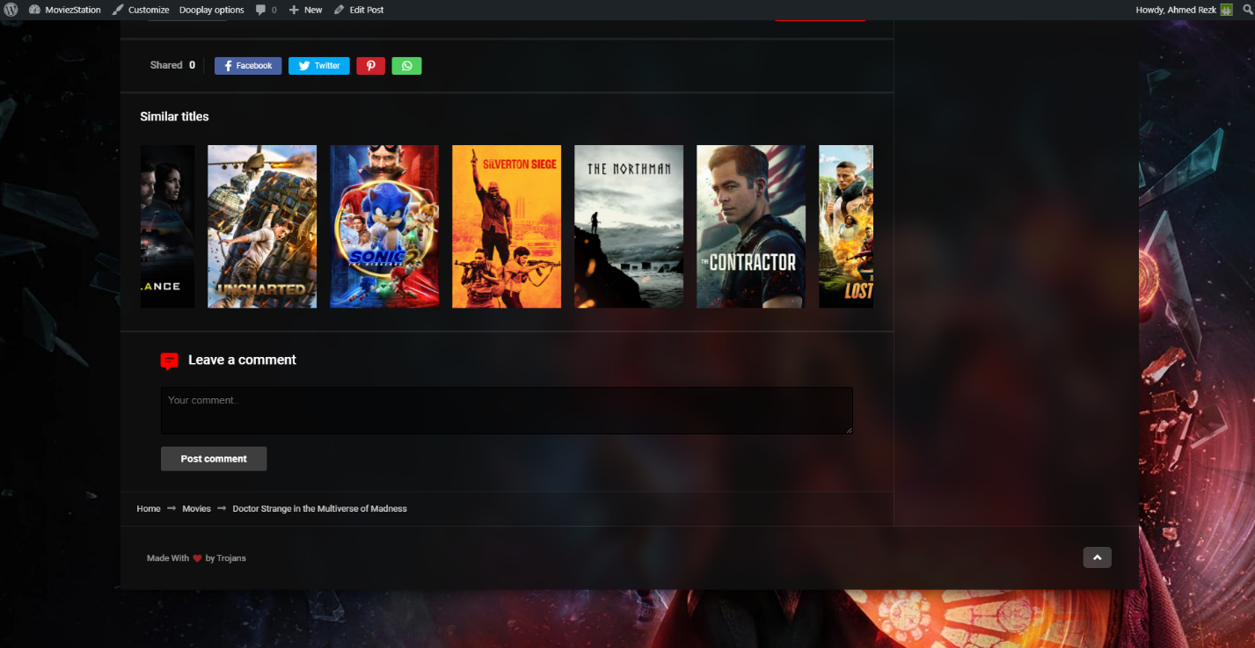

**Page that shows all the available episodes for the show (10):**

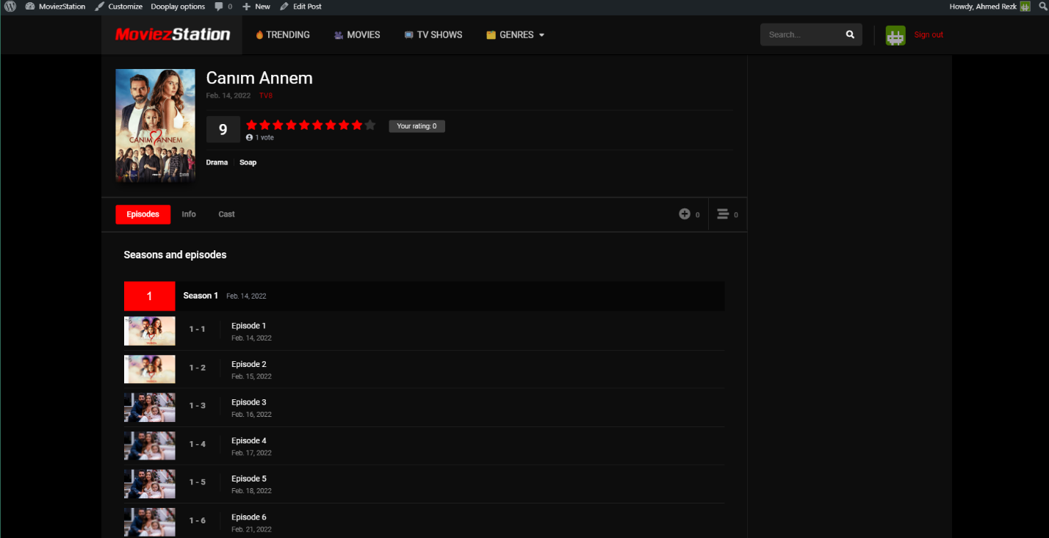

**In case the show isn’t available on the site it will show this message for the user (11):**

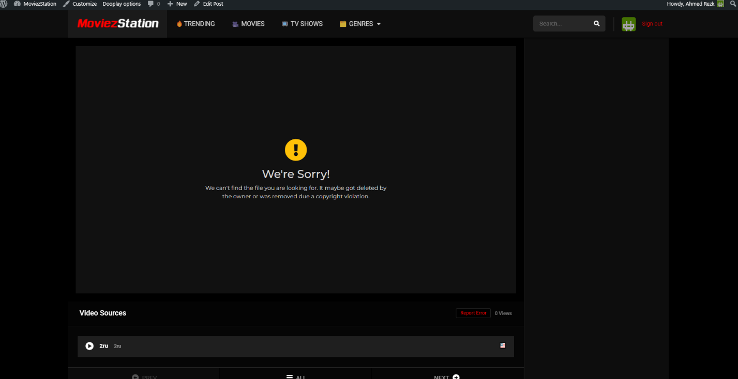

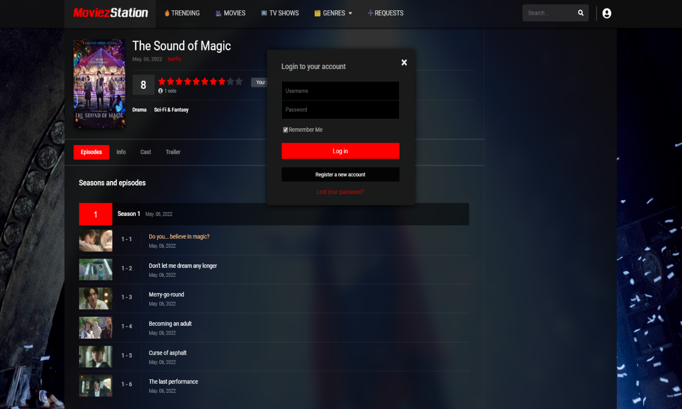**Login page for end-user (12):**

# ***Chapter 4: System Testing***

### 4.1 Open a movie and run the video player

***T1: Open a movie and run video player***

|  |  |  |  |
| --- | --- | --- | --- |
| **Test Number** | **Screen Number** | **Valid/Invalid** | **Description** |
| T1 | Screen 7&8 | The movie exists in the database | The video player starts running |
| T2 | Screen 11 | The movie is not in database | An error message is shown |

***T2: Valid email and password***

### 4.2 Valid email and password

|  |  |  |  |
| --- | --- | --- | --- |
| **Test Number** | **Screen Number** | **Valid/Invalid** | **Description** |
| T1 | Screen 11 | Valid email and password | End-user is logged into his/her account |
| T2 | Screen 11 | Invalid email and/or password | The error message shown |